Zambia

## Political Stability Estimate Data

The data set shows the political stability estimate of the country each year.

## # A tibble: 19 x 5  
## country iso3c date stability stabilityCategory4   
## <chr> <chr> <dbl> <dbl> <chr>   
## 1 Zambia ZMB 1996 -0.159 moderately unstable  
## 2 Zambia ZMB 1998 0.220 moderately stable   
## 3 Zambia ZMB 2000 0.0339 moderately stable   
## 4 Zambia ZMB 2002 -0.279 moderately unstable  
## 5 Zambia ZMB 2003 0.218 moderately stable   
## 6 Zambia ZMB 2004 0.190 moderately stable   
## 7 Zambia ZMB 2005 0.105 moderately stable   
## 8 Zambia ZMB 2006 0.363 moderately stable   
## 9 Zambia ZMB 2007 0.363 moderately stable   
## 10 Zambia ZMB 2008 0.470 moderately stable   
## 11 Zambia ZMB 2009 0.568 moderately stable   
## 12 Zambia ZMB 2010 0.515 moderately stable   
## 13 Zambia ZMB 2011 0.510 moderately stable   
## 14 Zambia ZMB 2012 0.661 moderately stable   
## 15 Zambia ZMB 2013 0.436 moderately stable   
## 16 Zambia ZMB 2014 0.156 moderately stable   
## 17 Zambia ZMB 2015 0.152 moderately stable   
## 18 Zambia ZMB 2016 0.143 moderately stable   
## 19 Zambia ZMB 2017 0.110 moderately stable

## Political Stability Estimate Plot

The plot shows the trends of stabilization and destabilization for the each country.

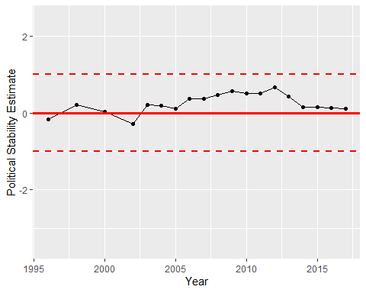

Political Stability Trend